**Experiment 6**

**Aim:**

To write an ARM Assembly Language to find the number of 1’s and 0’s in a given word.

**Tool Used:**

Keil uVision4

**Theory:**

LDR is used to load the Register with certain memory. RRX rotates the value of the register and store the left most bit to carry, and bring the carry bit if appended at the right most bit. ADDCS adds the value if the carry flag is set.

**Code:**

 AREA PROGRAM, CODE, READONLY

 ENTRY

MAIN

    MOV R0, #32

    LDR R1, =0X00001000

    LDR R2, [R1]

LOOP

    MOVS R2, R2, RRX

    ADDCS R3, R3, #1

    SUBS R0, R0, #1

    BNE LOOP

    RSB R4, R3, #32

    END

**Memory content**

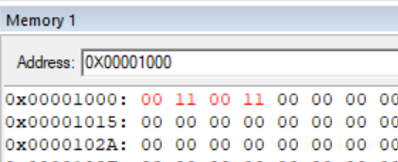

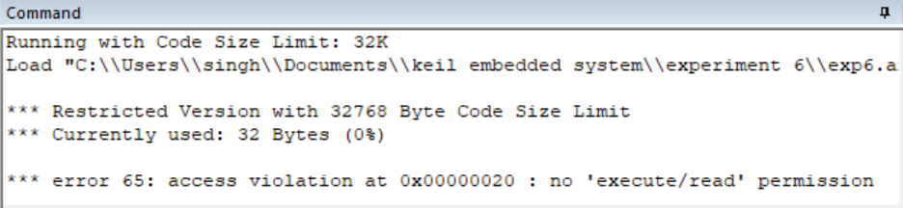

**Register Contents**

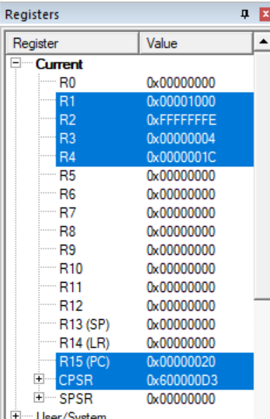

**Result:**

The experiments on compare operation have been performed and verified to be correct.